C:\Users\Ashish Kumar Namdeo\Desktop\logo_small_word.tif

**STUDENTS’ GYMKHANA ELECTIONS**

**Year 2018-19**

Indian Institute of Technology, Guwahati

**Nomination Form**

File Ref: IITG/SAC/GYM18/Elections/Nominations/

Post contesting for: PG SENATORS

**Candidate details:**

|  |  |
| --- | --- |
| Name: KRISHAN KUMAR | |
| Roll No.: 146106035 | Dept. /Branch: BSBE |
| CPI: 7.25 (COURSE WORK)  Backlogs: NO | Semester: SEVENTH  Active Backlogs (if any): NO |
| Email Id: krishan.kumar@iitg.ernet.in | Contact No.: 8812062555 |
| Hostel: Lohit | Room No.: C/101 |

Signature with date:

**Proposed by:**

|  |  |
| --- | --- |
| Name: ABHIJEET THAKUR | |
| Roll No.: 156106027 | Dept. /Branch: BSBE |
| CPI: 7.3 (COURSE WORK) | Semester: SIXTH |
| Email Id: [abhijeet.thakur@iitg.ernet.in](mailto:abhijeet.thakur@iitg.ernet.in) | Contact No.: 9954248520 |
| Hostel: Brahamputa | Room No.: f-99 |

Signature with date:

**Seconded by:**

|  |  |
| --- | --- |
| Name: PRIYANKA NATH | |
| Roll No.: 146106042 | Dept. /Branch: BSBE |
| CPI: 7.25(COURSE WORK) | Semester: SEVENTH |
| Email Id: [priyanka.nath@iitg.ernet.in](priyanka.nath@iitg.ernet.in%20) | Contact No.: 8472845300 |
| Hostel: SWH | Room No.: D-127 |

Signature with date:

C:\Users\Ashish Kumar Namdeo\Desktop\logo_small_word.tif

**STUDENTS’ GYMKHANA ELECTIONS**

**Year 2018-19**

Indian Institute of Technology, Guwahati

File Ref: IITG/SAC/GYM18/Elections/Agenda/

Post contesting for: PG SENATORS

|  |
| --- |
| Name: KRISHAN KUMAR |
| Nick Name.: |
| Tagline (Punch line): Be happy and make others happy |

**Agendas:**

**Agenda 1: HRA facility to student who is residing outside the campus.**

*Domain: Academic*

Proposal: PhD scholars who got married and have not got accommodation in married scholar hostel should get the HRA for living outside with their family. Or the student who has compulsion (diseases/family problem) to live outside also should get HRA.

Possible solution: According to the rule of MHRD, if a student is unable to get accommodation within the campus, then he/she will be eligible for HRA. If academic section is ready for this, then minor changes will be required for providing this facility.

Plan of Action: If I am elected as senator, I will put this agenda into official senate meeting for discussion. After having a constructive debate, the action plan will be proposed considering the views of every member of Gymkhana council.

Extra sheets may be attached if needed.

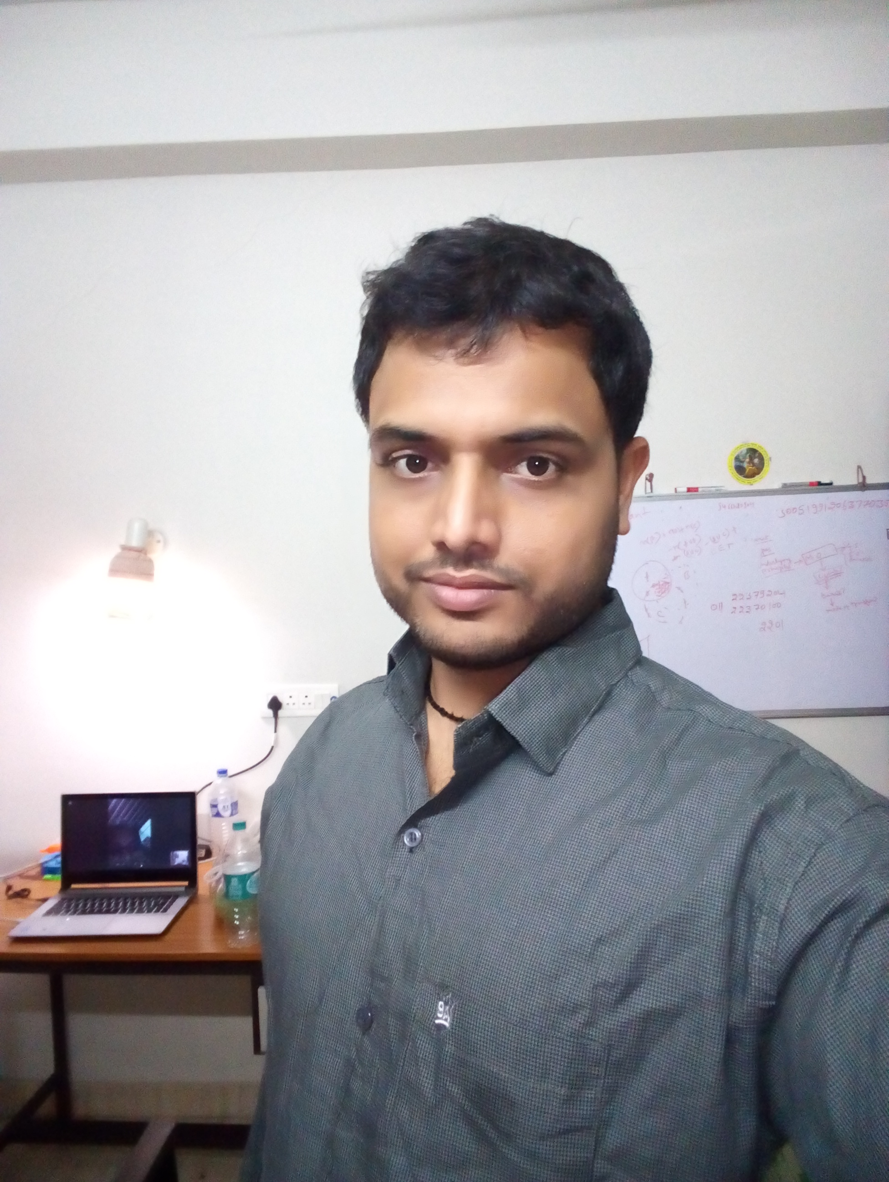

Photo graph

**Agendas and Declaration Form**

**Agenda 2: Hike in travel allowance and contingency,**

*Domain: Academic*

Proposal: Travelling allowance what we are getting is not enough to attend a single conference outside the campus and the contingency allotted to each students only five thousand that is not sufficient for one year.

Possible solution: Increase the amount of both TA and contingency as DST and CSIR giving to their students.

Plan of Action: If I am elected as senator, I will put this agenda into official senate meeting for discussion. After having a constructive debate, the action plan will be proposed considering the views of every member of Gymkhana council.

**Agenda 3: Prize for publication**

*Domain: Incentives to students*

Proposal: I propose to IITG administration to give some kind of prize (money or certificate) for Ph.D. students for the best publication in their respective department or center. This will encourage students to pay more concentration in research and ultimately lift the research excellence of IITG.

Possible solution: Small amount of fund should be allocated to all department and center of the IITG for this purpose.

Plan of Action: If I am elected as senator, I will put this agenda into official senate meeting for discussion. After having a constructive debate, the action plan will be proposed considering the views of every member of Gymkhana council

**Agenda 4: Lab rotation before supervisor allotment**

*Domain: Academic*

Proposal: In many department PhD students are allotted to supervisor without their consent. So it should be mutual choice of both student and supervisor.

Possible solution: Selected PhD students will visit lab according to his/her interest and will approach to the respective faculty for supervising him/her.

Plan of Action: If I am elected as senator, I will put this agenda into official senate meeting for discussion. After having a constructive debate, the action plan will be proposed considering the views of every member of Gymkhana council.

Extra sheets may be attached if needed.

**Declaration by the candidate:**

I hereby declare that the above information is to the best of my knowledge. I do not have any disciplinary probation by the Institute and will abide by the rules and regulations laid for Gymkhana Election. I do not have any active backlogs to be cleared.

I know that any false information in this nomination form will lead to cancellation of my nomination and disciplinary action.

Signature of candidate with date: Signature of CEO

Former Senate member of my graduation university (Sambalpur University, Odisha, 2011-2012)

**Experiences (Credentials if any):**